Week 3

Topics: STL, Stack and Queue using STL

1) Q.1. Write a program using the stack STL to implement the following :

Input : push(1), push(2), push(4), push(5), pop, pop

#include <iostream>

#include <stack>

using namespace std;

int main() {

stack<int> st;

st.push(1);

st.push(2);

st.push(4);

st.push(5);

st.pop();

st.pop();

while (!st.empty()) {

cout << ' ' << st.top();

st.pop();

}

}

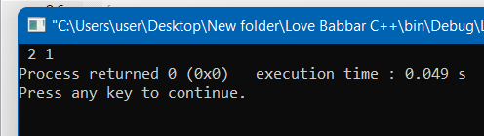

Q2) Write a program using the Queue STL to find the sum of the all the integers for a given queue of

integers.

Input : 3, 7, 4, 5, 1

Output : 20

#include <iostream>

#include <queue>

using namespace std;

int main()

{

int sum=0;

queue<int> q;

q.push(3);

q.push(7);

q.push(4);

q.push(5);

q.push(1);

while (!q.empty()) {

sum+= q.front();

q.pop();

}

cout<<sum;

return 0; }

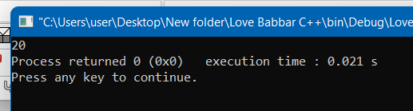

Q.3. write a program using stack STL to swap the content of one stack with another stack of same type

Input : stack1 = {41, 33, 20, 11}

stack2 = {90, 75 ,58, 35}

Output : stack1 = 90, 75, 58, 35

stack2 = 41, 33, 20, 11

#include <stack>

#include <iostream>

using namespace std;

int main()

{

stack<int> stack1;

stack<int> stack2;

stack1.push(41);

stack1.push(33);

stack1.push(20);

stack1.push(11);

stack2.push(90);

stack2.push(75);

stack2.push(58);

stack2.push(35);

swap(stack1, stack2);

cout<<"stack1: ";

while (!stack1.empty()) {

cout<<stack1.top()<<" ";

stack1.pop();

}

cout<<"stack2: ";

while (!stack2.empty()) {

cout<<stack2.top()<<" ";

stack2.pop(); }

return 0;

}

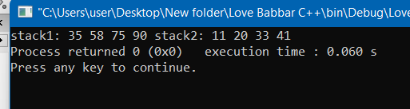

4)

Output:

2

1

5)

Reverse the entire queue

6)

Output: 34 76 TUTORIAL-4